Croquet Foundation of America
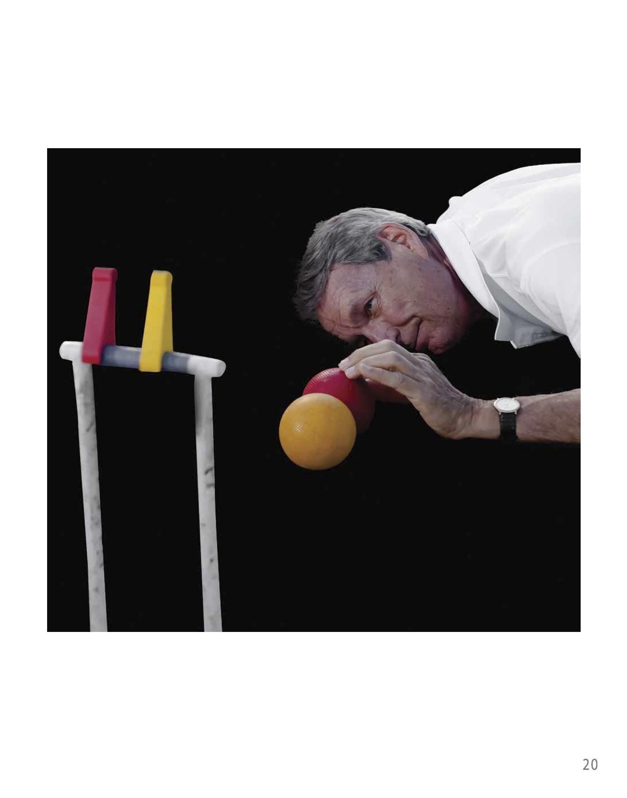
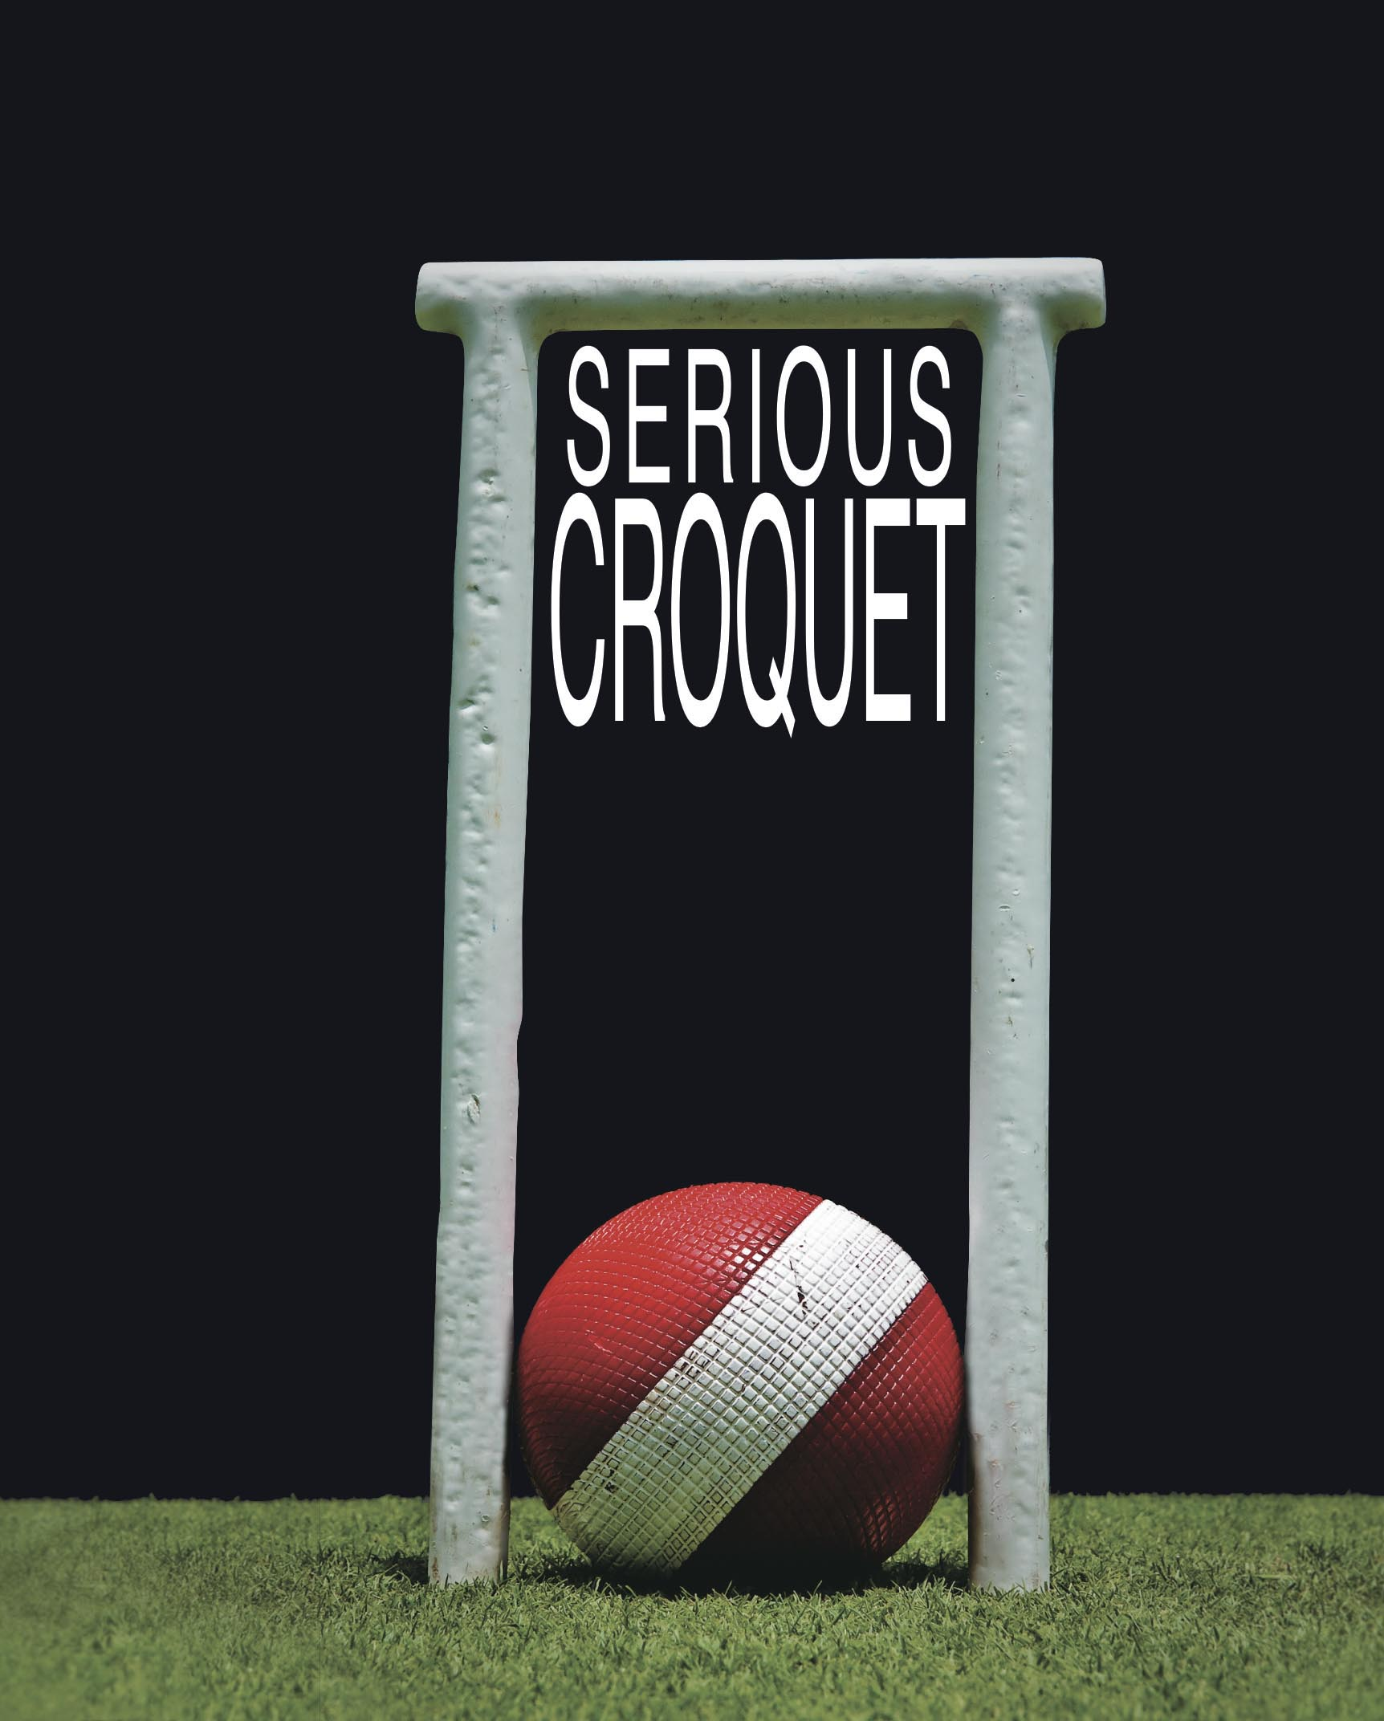
Yes, I want a copy of the first edition book
“SERIOUS CROQUET”
To view the photographs visit:
www.chiltonpics.com
Enter Site, Click on Galleries then “Serious Croquet”

Please send me the following:

1.“Serious Croquet” -- Collectors’ Edition: Presentation Slipcase, signed by the authors and numbered (only 200 available, subject to prior sale), plus an 8x10 gallery-quality photograph of your choice. Please indicate your choice here by description or name of player__________________________________________________
Price: $300 X ___copies plus 6% Florida Tax ($18.00 each) = $ _________.
2. “Serious Croquet” – First Edition Book, Presentation Slipcase.
Price: $100 X ___copies, plus 6% Florida Tax of $6.00 each = $ _________.
3. ”Serious Croquet” -- First Edition Book.
$50 X ___copies, plus 6% Florida Sales Tax of $3.00 each = $ _________.
Shipping and Handling (Collectors’ Edition free): $20 each $ _________.
Total Order. Please: ☐ Charge my card ☐ Check enclosed for: $ _________.
(Please make checks payable to “Croquet Foundation of America”)
City_____________________________________________ State _______________ Zip __________
Credit Card: ☐Visa ☐Master Card ☐ AMEX Number _________________________ Exp. Date__________
Name_____________________________________________________________________________________
Shipping Address________________________________________________________________________
Signature _________________________________________________________________________________

Fax to Bobbi Segal: (561) 471-0832 or mail to 700 Florida Mango Road, W. Palm Beach, FL 33404
_________________________________________________________________________________________________________________________

One hundred percent of the proceeds from this book will be used to advance the programs and operations of the Croquet Foundation of America and the United States Croquet Association; both are 501 (c) (3) tax-exempt corporations dedicated to the promotion and advancement of the amateur sport of croquet.

The Croquet Foundation of America, Inc., a New York not-for-profit corporation, is a publicly supported qualified tax-exempt charitable organization under section 501(c)(3) of the Internal Revenue Code of 1986, as amended, contributions to which are tax deductible within the limitations provided by law. The Federal Taxpayer Identification Number is: 13-3008386.

The Croquet Foundation of America receives 100% of each contribution. A COPY OF THE OFFICIAL REGISTRATION AND FINANCIAL INFORMATION OF THE CROQUET FOUNDATION OF AMERICA, (CH 4098), MAY BE OBTAINED FROM THE DIVISION OF CONSUMER SERVICES BY CALLING TOLL FREE 1-800 435-7352 WITHIN THE STATE OF FLORIDA. REGISTRATION DOES NOT IMPLY ENDORSEMENT, APPROVAL OR RECOMMENDATION BY THE STATE.

